1. Go to your PWP page (eg. <http://www.imperial.ac.uk/people/p.angeloudis>)
2. Look for the “Log in” image at the footer
3. After logging in, press edit profile
4. Press the Edit icon for the main text
5. 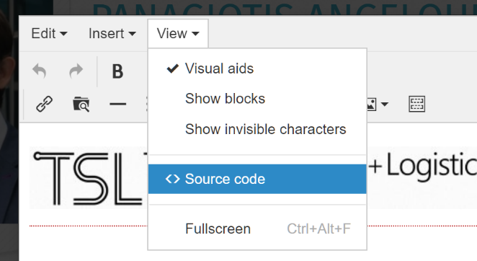Once the editor is open, switch to the source code view
6. At the top of the source code view, add the below snippet:

<p><a href="http://www.tslab.org"><img class="ct full" src="//www.imperial.ac.uk/ImageCropToolT4/imageTool/uploaded-images/logo-pwp--tojpeg_1557131628413_x1.jpg?r=7924" alt="tslab-logo" /></a></p>

<br>

It should now look roughly like this:

